monkey-blog

[元数据建模信息有限公司]

|  |
| --- |
| 花果山博客 |

文档信息

|  |  |  |  |
| --- | --- | --- | --- |
| 项目名称： | monkey-blog | | |
| 项目经理： | 杨松<yangsong158@qq.com> | 模型编号： | 4.3.0 |
| 模型创建日期： | 2023-6-9 18:08:56 | 模型更新日期： | 2023-6-9 20:09:47 |
| 起草人： | 元数建模自动生成 | 文档创建日期： |  |
| 复审人： | 杨松<yangsong158@qq.com> | 复审日期： |  |
| 项目说明： | 花果山博客 | | |
| 官方网站： | <http://www.chiner.com.cn/> | | |
| 开源代码： | <https://gitee.com/robergroup/chiner.git>  <https://gitee.com/robergroup/chiner-java.git> | | |
| 联系作者： |  | | |

# PDManer元数建模-monkey-blog

## 关系图

### 用户-[用户关系图]

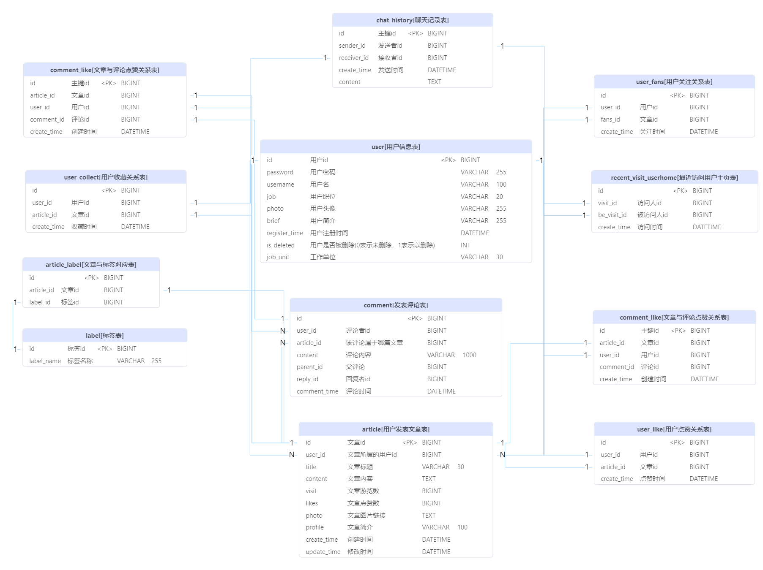

## 表清单

|  |  |  |  |
| --- | --- | --- | --- |
| **#** | **数据表** | **名称** | **备注说明** |
| 1 | article | 用户发表文章表 |  |
| 2 | article_label | 文章与标签对应表 |  |
| 3 | chat_history | 聊天记录表 |  |
| 4 | comment | 发表评论表 |  |
| 5 | comment_like | 文章与评论点赞关系表 |  |
| 6 | label | 标签表 |  |
| 7 | recent_visit_userhome | 最近访问用户主页表 |  |
| 8 | sys_dict_data | 数据字典内容 |  |
| 9 | sys_dict_type | 数据字典类型 |  |
| 10 | user | 用户信息表 |  |
| 11 | user_collect | 用户收藏关系表 |  |
| 12 | user_fans | 用户关注关系表 |  |
| 13 | user_like | 用户点赞关系表 |  |

## 表字段明细

### article [用户发表文章表]

|  |  |  |  |  |  |  |  |
| --- | --- | --- | --- | --- | --- | --- | --- |
| **#** | **字段** | **名称** | **数据类型** | **主键** | **非空** | **默认值** | **备注说明** |
| 1 | id | 文章id | BIGINT | √ | √ |  |  |
| 2 | user_id | 文章所属的用户id | BIGINT |  |  |  |  |
| 3 | title | 文章标题 | VARCHAR(30) |  |  |  |  |
| 4 | content | 文章内容 | TEXT |  |  |  |  |
| 5 | visit | 文章游览数 | BIGINT |  |  | 0 |  |
| 6 | likes | 文章点赞数 | BIGINT |  |  | 0 |  |
| 7 | photo | 文章图片链接 | TEXT |  |  |  |  |
| 8 | profile | 文章简介 | VARCHAR(100) |  |  |  |  |
| 9 | create_time | 创建时间 | DATETIME |  |  |  |  |
| 10 | update_time | 修改时间 | DATETIME |  |  |  |  |

### article_label [文章与标签对应表]

|  |  |  |  |  |  |  |  |
| --- | --- | --- | --- | --- | --- | --- | --- |
| **#** | **字段** | **名称** | **数据类型** | **主键** | **非空** | **默认值** | **备注说明** |
| 1 | id |  | BIGINT | √ | √ |  |  |
| 2 | article_id | 文章id | BIGINT |  |  |  |  |
| 3 | label_id | 标签id | BIGINT |  |  |  |  |

### chat_history [聊天记录表]

|  |  |  |  |  |  |  |  |
| --- | --- | --- | --- | --- | --- | --- | --- |
| **#** | **字段** | **名称** | **数据类型** | **主键** | **非空** | **默认值** | **备注说明** |
| 1 | id | 主键id | BIGINT | √ | √ |  |  |
| 2 | sender_id | 发送者id | BIGINT |  |  |  |  |
| 3 | receiver_id | 接收者id | BIGINT |  |  |  |  |
| 4 | create_time | 发送时间 | DATETIME |  |  |  |  |
| 5 | content |  | TEXT |  |  |  |  |
|  |  |  |  |  |  |  |  |

### comment [发表评论表]

|  |  |  |  |  |  |  |  |
| --- | --- | --- | --- | --- | --- | --- | --- |
| **#** | **字段** | **名称** | **数据类型** | **主键** | **非空** | **默认值** | **备注说明** |
| 1 | id |  | BIGINT | √ | √ |  |  |
| 2 | user_id | 评论者id | BIGINT |  |  |  |  |
| 3 | article_id | 该评论属于哪篇文章 | BIGINT |  |  |  |  |
| 4 | content | 评论内容 | VARCHAR(1000) |  |  |  |  |
| 5 | parent_id | 父评论 | BIGINT |  |  | 0 |  |
| 6 | reply_id | 回复者id | BIGINT |  |  |  |  |
| 7 | comment_time | 评论时间 | DATETIME |  |  |  |  |

### comment_like [文章与评论点赞关系表]

|  |  |  |  |  |  |  |  |
| --- | --- | --- | --- | --- | --- | --- | --- |
| **#** | **字段** | **名称** | **数据类型** | **主键** | **非空** | **默认值** | **备注说明** |
| 1 | id | 主键id | BIGINT | √ | √ |  |  |
| 2 | article_id | 文章id | BIGINT |  |  |  |  |
| 3 | user_id | 用户id | BIGINT |  |  |  |  |
| 4 | comment_id | 评论id | BIGINT |  |  |  |  |
| 5 | create_time | 创建时间 | DATETIME |  |  |  |  |

### label [标签表]

|  |  |  |  |  |  |  |  |
| --- | --- | --- | --- | --- | --- | --- | --- |
| **#** | **字段** | **名称** | **数据类型** | **主键** | **非空** | **默认值** | **备注说明** |
| 1 | id | 标签id | BIGINT | √ | √ |  |  |
| 2 | label_name | 标签名称 | VARCHAR(255) |  |  |  |  |

### recent_visit_userhome [最近访问用户主页表]

|  |  |  |  |  |  |  |  |
| --- | --- | --- | --- | --- | --- | --- | --- |
| **#** | **字段** | **名称** | **数据类型** | **主键** | **非空** | **默认值** | **备注说明** |
| 1 | id |  | BIGINT | √ | √ |  |  |
| 2 | visit_id | 访问人id | BIGINT |  |  |  |  |
| 3 | be_visit_id | 被访问人id | BIGINT |  |  |  |  |
| 4 | create_time | 访问时间 | DATETIME |  |  |  |  |

### sys_dict_data [数据字典内容]

|  |  |  |  |  |  |  |  |
| --- | --- | --- | --- | --- | --- | --- | --- |
| **#** | **字段** | **名称** | **数据类型** | **主键** | **非空** | **默认值** | **备注说明** |
| 1 | id | 主键id | BIGINT | √ | √ |  |  |
| 2 | dict_sort | 字典排序 | INT |  |  |  |  |
| 3 | dict_label | 字典标签 | VARCHAR(30) |  |  |  |  |
| 4 | dict_value | 字典值 | INT |  |  |  |  |
| 5 | dict_type | 字典类型 | VARCHAR(30) |  |  |  |  |
| 6 | status | 状态 | INT |  |  | 0 |  |

### sys_dict_type [数据字典类型]

|  |  |  |  |  |  |  |  |
| --- | --- | --- | --- | --- | --- | --- | --- |
| **#** | **字段** | **名称** | **数据类型** | **主键** | **非空** | **默认值** | **备注说明** |
| 1 | id | 字典主键 | BIGINT | √ | √ |  |  |
| 2 | dict_name | 字典名称 | VARCHAR(30) |  |  |  |  |
| 3 | dict_type | 字典类型 | VARCHAR(30) |  |  |  |  |
| 4 | status | 状态 | INT |  |  | 0 |  |

### user [用户信息表]

|  |  |  |  |  |  |  |  |
| --- | --- | --- | --- | --- | --- | --- | --- |
| **#** | **字段** | **名称** | **数据类型** | **主键** | **非空** | **默认值** | **备注说明** |
| 1 | id | 用户id | BIGINT | √ | √ |  |  |
| 2 | password | 用户密码 | VARCHAR(255) |  |  |  |  |
| 3 | username | 用户名 | VARCHAR(100) |  |  | '猴子' |  |
| 4 | job | 用户职位 | VARCHAR(20) |  |  |  |  |
| 5 | photo | 用户头像 | VARCHAR(255) |  |  |  |  |
| 6 | brief | 用户简介 | VARCHAR(255) |  |  | '这个人很懒，什么都没留下' |  |
| 7 | register_time | 用户注册时间 | DATETIME |  |  |  |  |
| 8 | is_deleted | 用户是否被删除(0表示未删除，1表示以删除) | INT |  |  | 0 |  |
| 9 | job_unit | 工作单位 | VARCHAR(30) |  |  |  |  |

### user_collect [用户收藏关系表]

|  |  |  |  |  |  |  |  |
| --- | --- | --- | --- | --- | --- | --- | --- |
| **#** | **字段** | **名称** | **数据类型** | **主键** | **非空** | **默认值** | **备注说明** |
| 1 | id |  | BIGINT | √ | √ |  |  |
| 2 | user_id | 用户id | BIGINT |  |  |  |  |
| 3 | article_id | 文章id | BIGINT |  |  |  |  |
| 4 | create_time | 收藏时间 | DATETIME |  |  |  |  |

### user_fans [用户关注关系表]

|  |  |  |  |  |  |  |  |
| --- | --- | --- | --- | --- | --- | --- | --- |
| **#** | **字段** | **名称** | **数据类型** | **主键** | **非空** | **默认值** | **备注说明** |
| 1 | id |  | BIGINT | √ | √ |  |  |
| 2 | user_id | 用户id | BIGINT |  |  |  |  |
| 3 | fans_id | 文章id | BIGINT |  |  |  |  |
| 4 | create_time | 关注时间 | DATETIME |  |  |  |  |

### user_like [用户点赞关系表]

|  |  |  |  |  |  |  |  |
| --- | --- | --- | --- | --- | --- | --- | --- |
| **#** | **字段** | **名称** | **数据类型** | **主键** | **非空** | **默认值** | **备注说明** |
| 1 | id |  | BIGINT | √ | √ |  |  |
| 2 | user_id | 用户id | BIGINT |  |  |  |  |
| 3 | article_id | 文章id | BIGINT |  |  |  |  |
| 4 | create_time | 点赞时间 | DATETIME |  |  |  |  |

## 数据字典明细